**Features**

**General:**

Kids is impressing with learning a word through image, supporting for both US/UK voice.

List of vocabularies will be displayed per level, there’re 9 levels as of now:

* Starter 1,2,3
* Pre Kid 1,2,3
* Smart Kid 1,2,3

**User's guide**

Step 1: Login is oligated to start learing and for reporting’s purpose.

Step 2: Choose the level, or minium level is by defaut

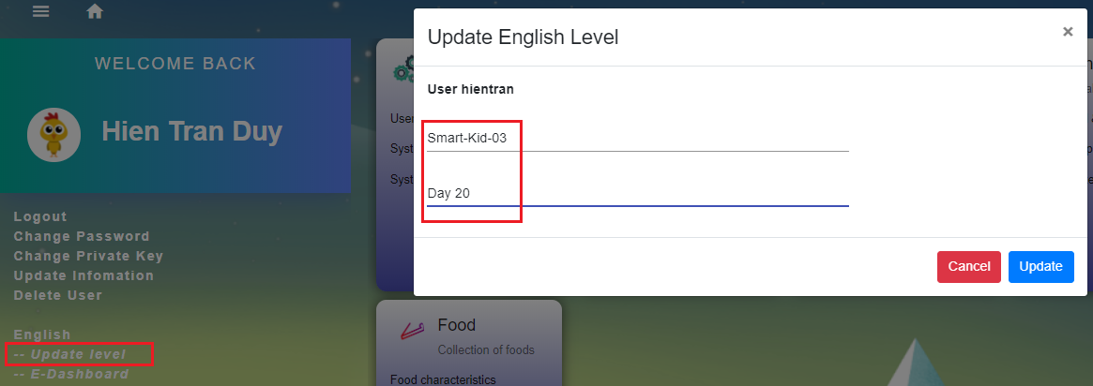

Step 3: Go to “English”

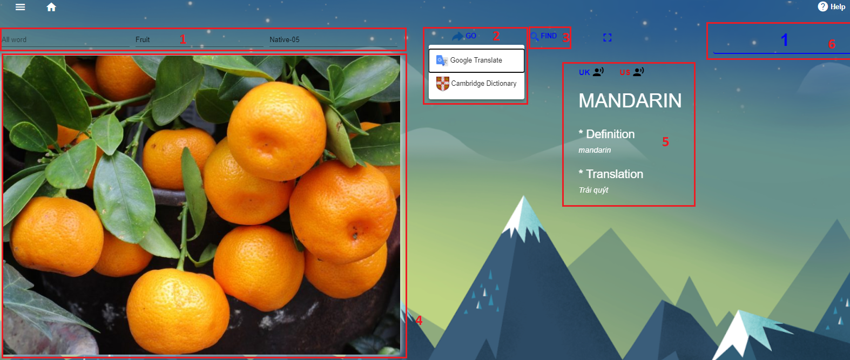

[1] User can either filter by:

- Specific word, or

- Favourite category (i.e animal, color, number,..), or

- Formal level

[2] “Go to” for further detals of a word, directly to Cambridge or Google page

[3] “Find” leads user to next word

[4] Clicking on for explaination

[5] Clicking on for hearning voice

[6] Count all the words that user learned today, clicking on for list of words

Step 4: Dashboard, showing your leaning history

